**Pizza Sales SQL Queries**

* **KPI’s**

1. **Total Revenue**

select round(sum(total_price),0) as Total_Revenue from sales;

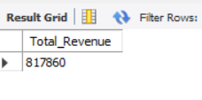

1. Total Order

select count(distinct(order_id)) as Total_Order from sales;

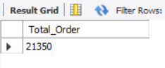

1. Total Pizza Sold

select sum(quantity) as Total_Pizza_Sold from sales;

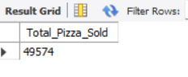

1. Average Order Price

select (round(sum(total_price)/count(distinct(order_id)),2)) as Average_Price from sales;

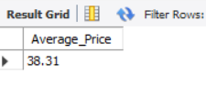

1. Average Pizza Sold per Order

select ( (sum(quantity)/count(distinct(order_id)),2)) as Average_Pizza_Sold from sales;

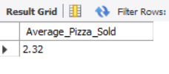

* Weekly Trend for Total Order

select dayofweek(order_date) as Weekdays , count(distinct (order_id)) as Total_Order from sales group by Weekdays;

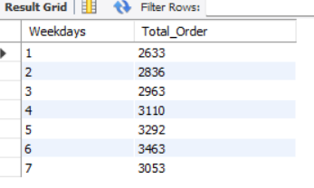

* Hourly Trend for Total Order

select hour(order_time) as Hour ,count(distinct (order_id)) as Total_Order from sales group by hour(order_time) ;

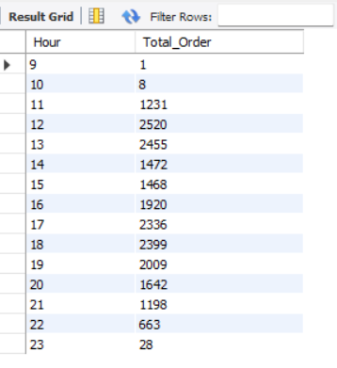

* % Sales by Pizza Category

select pizza_category , sum(total_price)*100/(select sum(total_price) from sales) as "% Sales" from sales group by pizza_category;

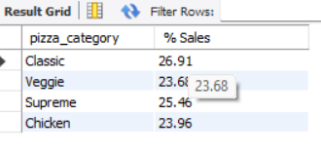

* % Sales by Pizza Size

select pizza_size , round(sum(total_price) *100/(select sum(total_price) from sales),2) as "% Sales" from sales group by pizza_size;

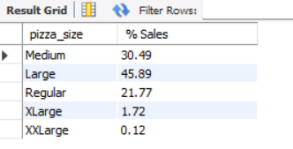

* Top Order by Pizza Category

select pizza_category , sum(quantity) as Total_Order from sales group by pizza_category order by sum(quantity) desc;

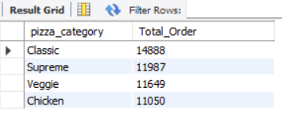

* Top 5 Pizza Ordered

select pizza_name , sum(quantity) as Total_Order from sales group by pizza_name order by Total_Order desc limit 5;

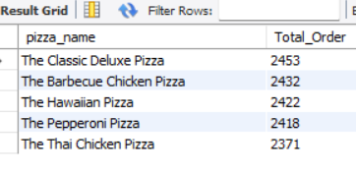

* Bottom 5 Pizza Ordered

select pizza_name,sum(quantity) as Total_Order from sales group by pizza_name order by Total_Order limit 5;

